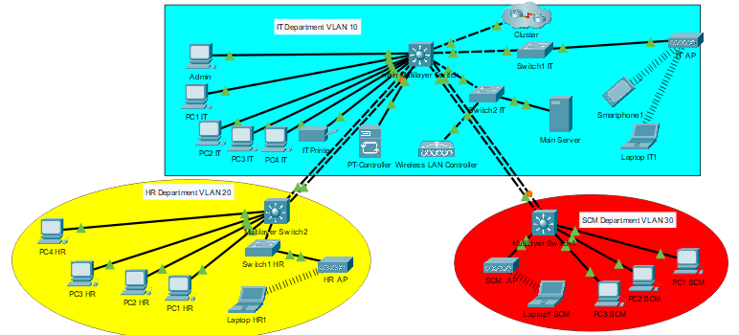Main multilayer switch:

Create vlans (10,20,30)and give names.

Give ip address to the vlans

To see the vlans

Show vlan brif

Give all port access except which connect with the other switch and cluster give trank.

Switch port mode access

Switch port mode trank

To make the connect save should make a port channel between the switches.

configure terminal

interface range gigabit Ethernet 0/1 - 2

channel-group 1

mode active

exit

interface port-channel 1

ip address 192.168.10.1 255.255.255.0

switch port mode trunk

no shutdown

exit

multilayer switch 1:

Create vlans (10,20,30)and give names.

Give ip address to the vlans

Give all port access mode.

Switch port mode access

multilayer switch 2:

Create vlans (10,20,30)and give names.

Give ip address to the vlans

Give all port access except which connect with the other switch give trank.

Switch port mode access

Switch port mode trank

Network controller(PT controller)

To check the testing and monitoring the network.

To connect with the controller go to the Admin pc then to the web browse and write the controller ip address.

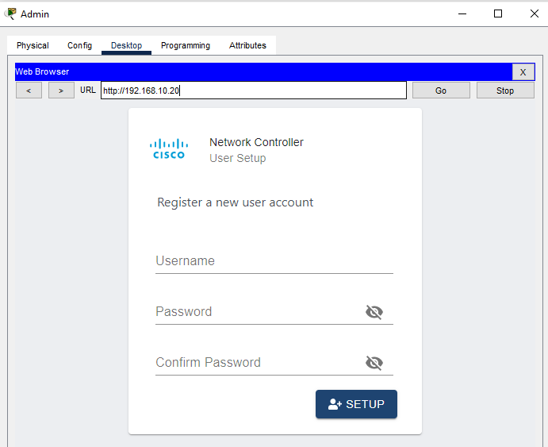

After login the controller will shoes a dashboard

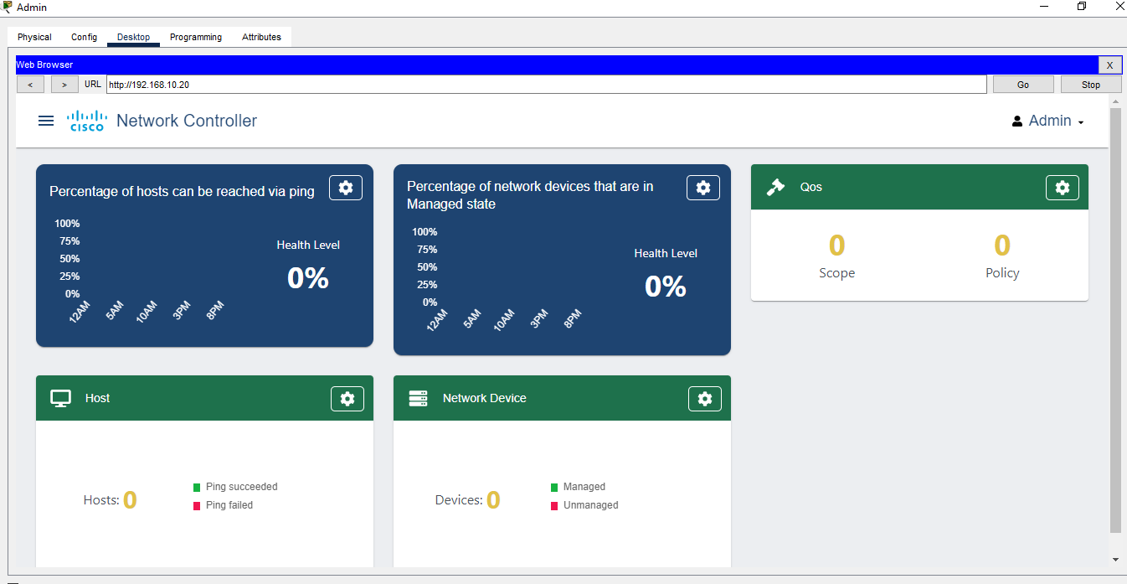

The dashboard shows a different choice that can we see and managed.

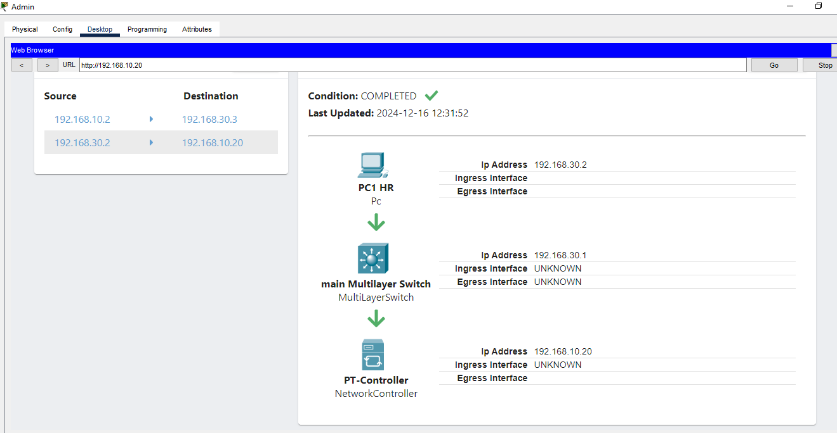

As this figure shows can see the connection bath when it is send any files or any data from this topology it shows that the data send from the source witch is PC1 in HR department then it arrive to the main switch then it stop to his destination in the controller.

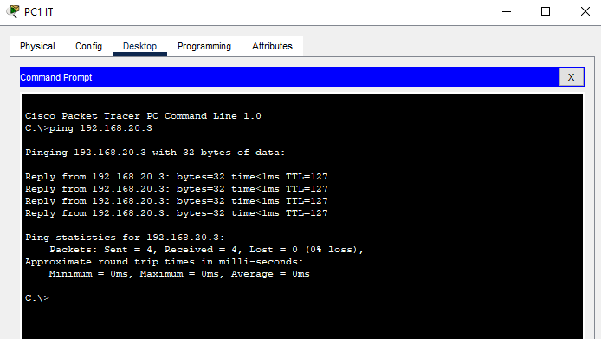 In this figure I check a pinging from the source which is PC1 in IT department to the destination which have a ip address 192.168.20.3

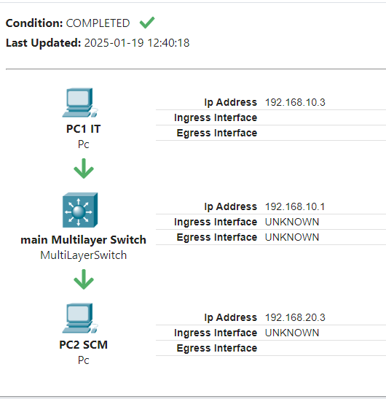

The same source and destination as figure above from the controller it shows the bath.